# EE M16 and CS M51A Winter 2019 Section 2

**Logic Design of Digital Systems**

**Dr. Yutao He**

# Verilog Lab #3 - Design of Sequential Systems

**Due: March 10, 2019**

**Team ID: ________P26_____________________**

1. **Name: ______Huynh_____________Derrick____________**

Last First

**Student ID: ____________705101279_________________**

**Signature: ______________Derrick Huynh___________________**

1. **Name: ______Xia________________Lucas__________**

Last First

**Student ID: ________005099109_______________**

**Signature: _____________Lucas Xia______________**

**Date: __________03/10/19________________**

|  |  |
| --- | --- |
| **Result** |  |
| **Correctness** |  |
| **Creativity** |  |
| **Report** |  |
| **Total Score** |  |

**Verilog Lab #3 Project**

1. *Abstract*

Implement a vending machine that takes in nickels and dimes and deposits gum and nickels with a finite state machine that uses JK flip flops. The FSM has 4 states, which represents empty, 5c, 10c, and 15c. The transition of states depends on the input of x1 and x0, the encoding for the coin values.

|  |  |  |  |
| --- | --- | --- | --- |
|  | **Inputs** | **Outputs** |  |
| **Variables** | **Values** | **Variables** | **Values** |
| Reset | {True (T),False (F)} | Release Gum (RG) | {T,F} |
| Coin | {Empty (E), Nickel (N), Dime (D) } | Return Nickel (RN) | {T,F} |

*Table 1: The Inputs and Outputs of the iKon Controller*

1. *The Functions of the Circuit*

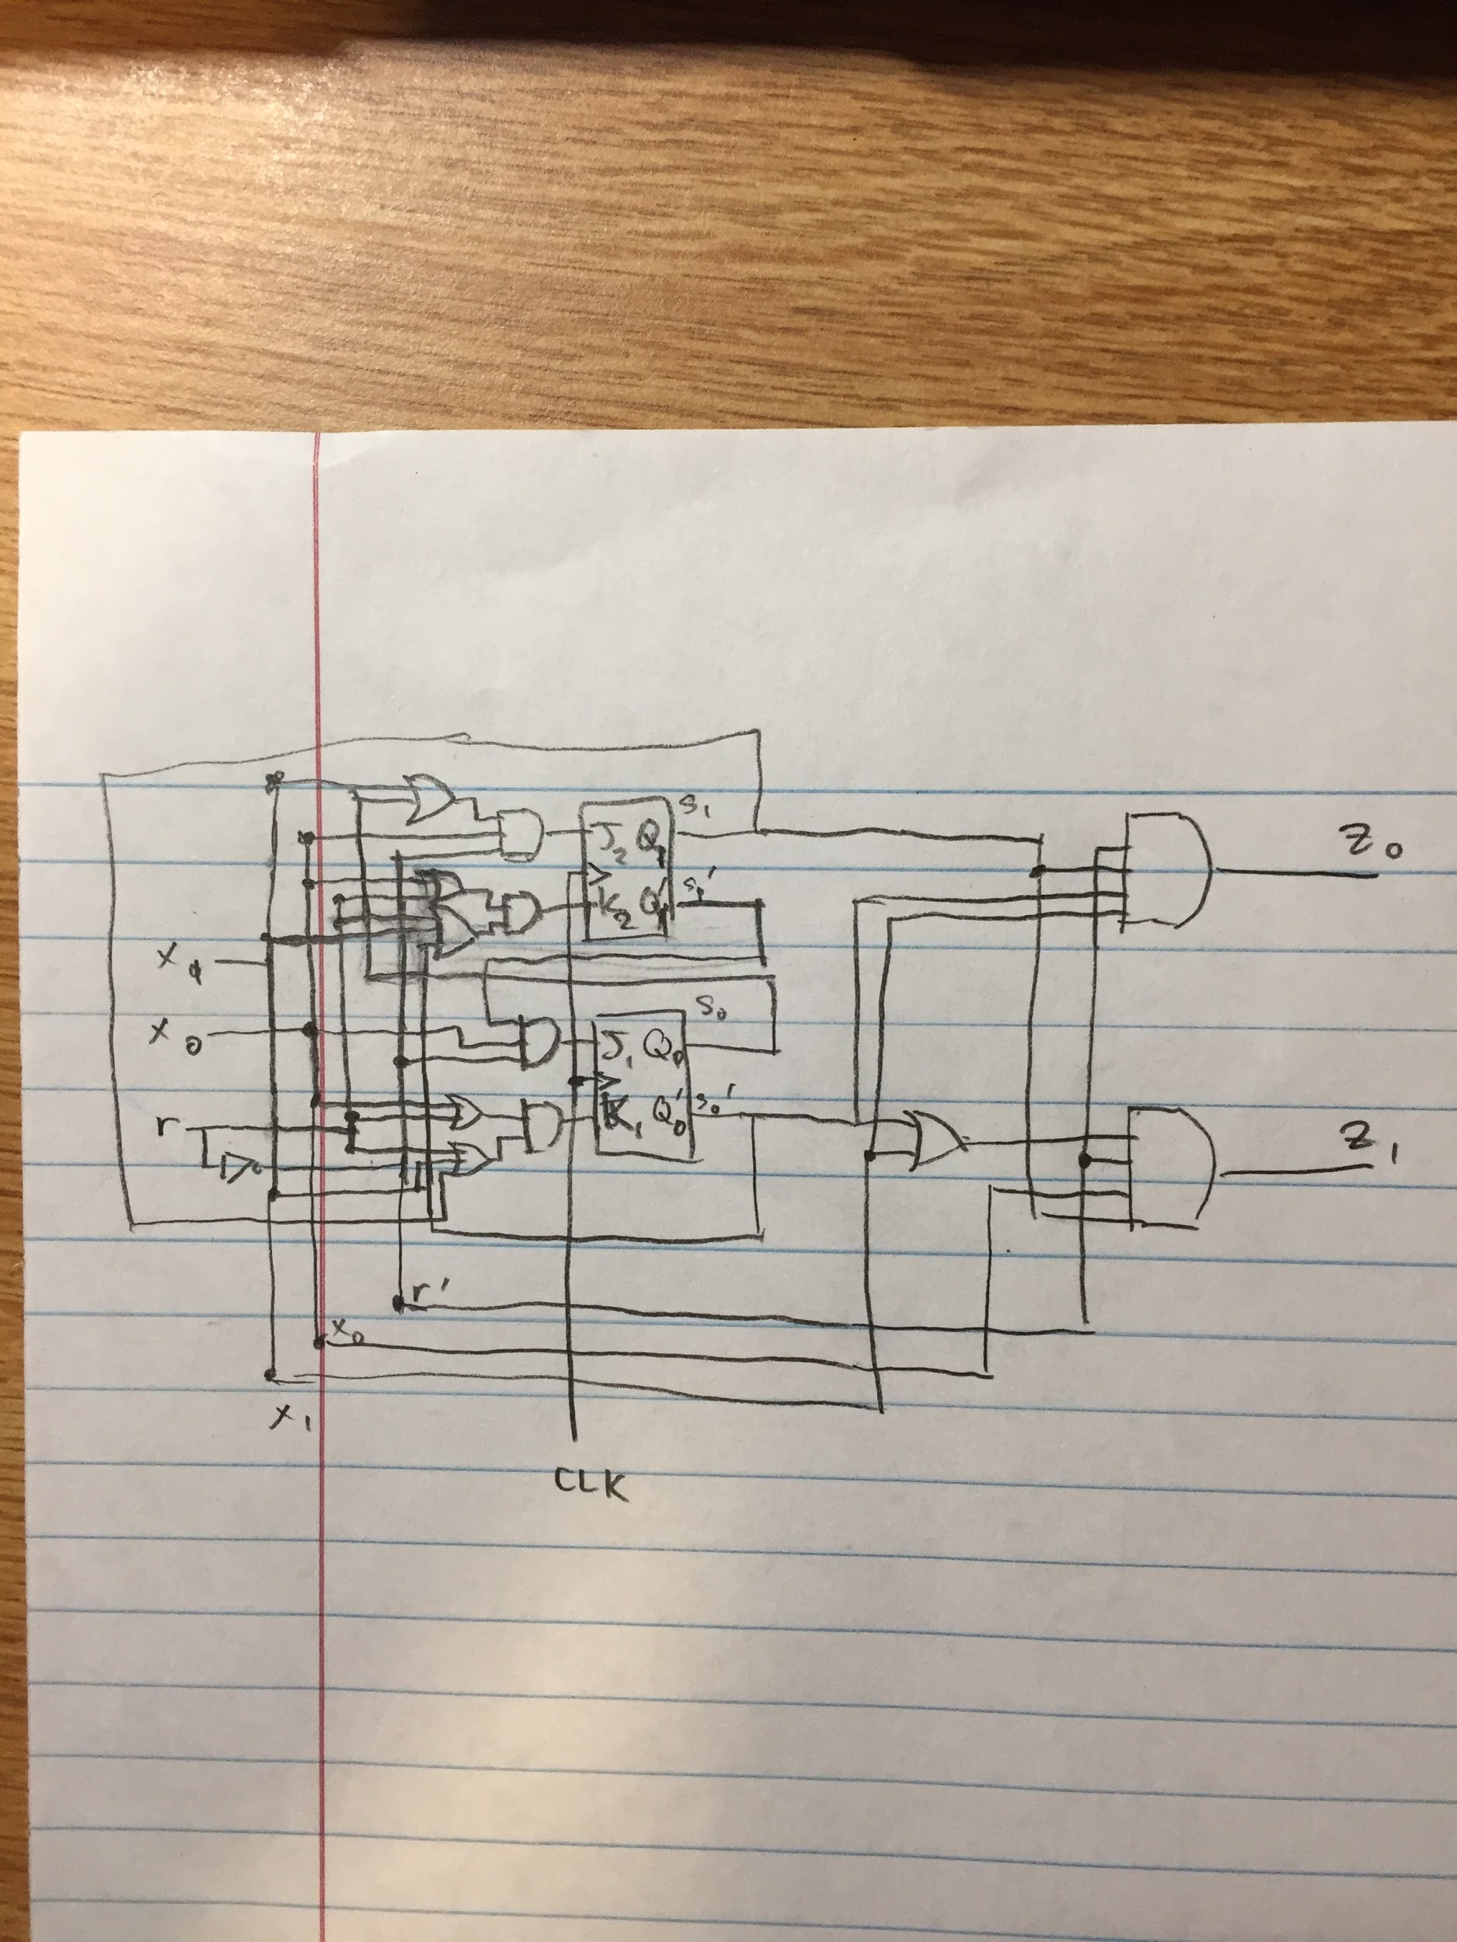 *Figure 1: Schematic of the FSM*

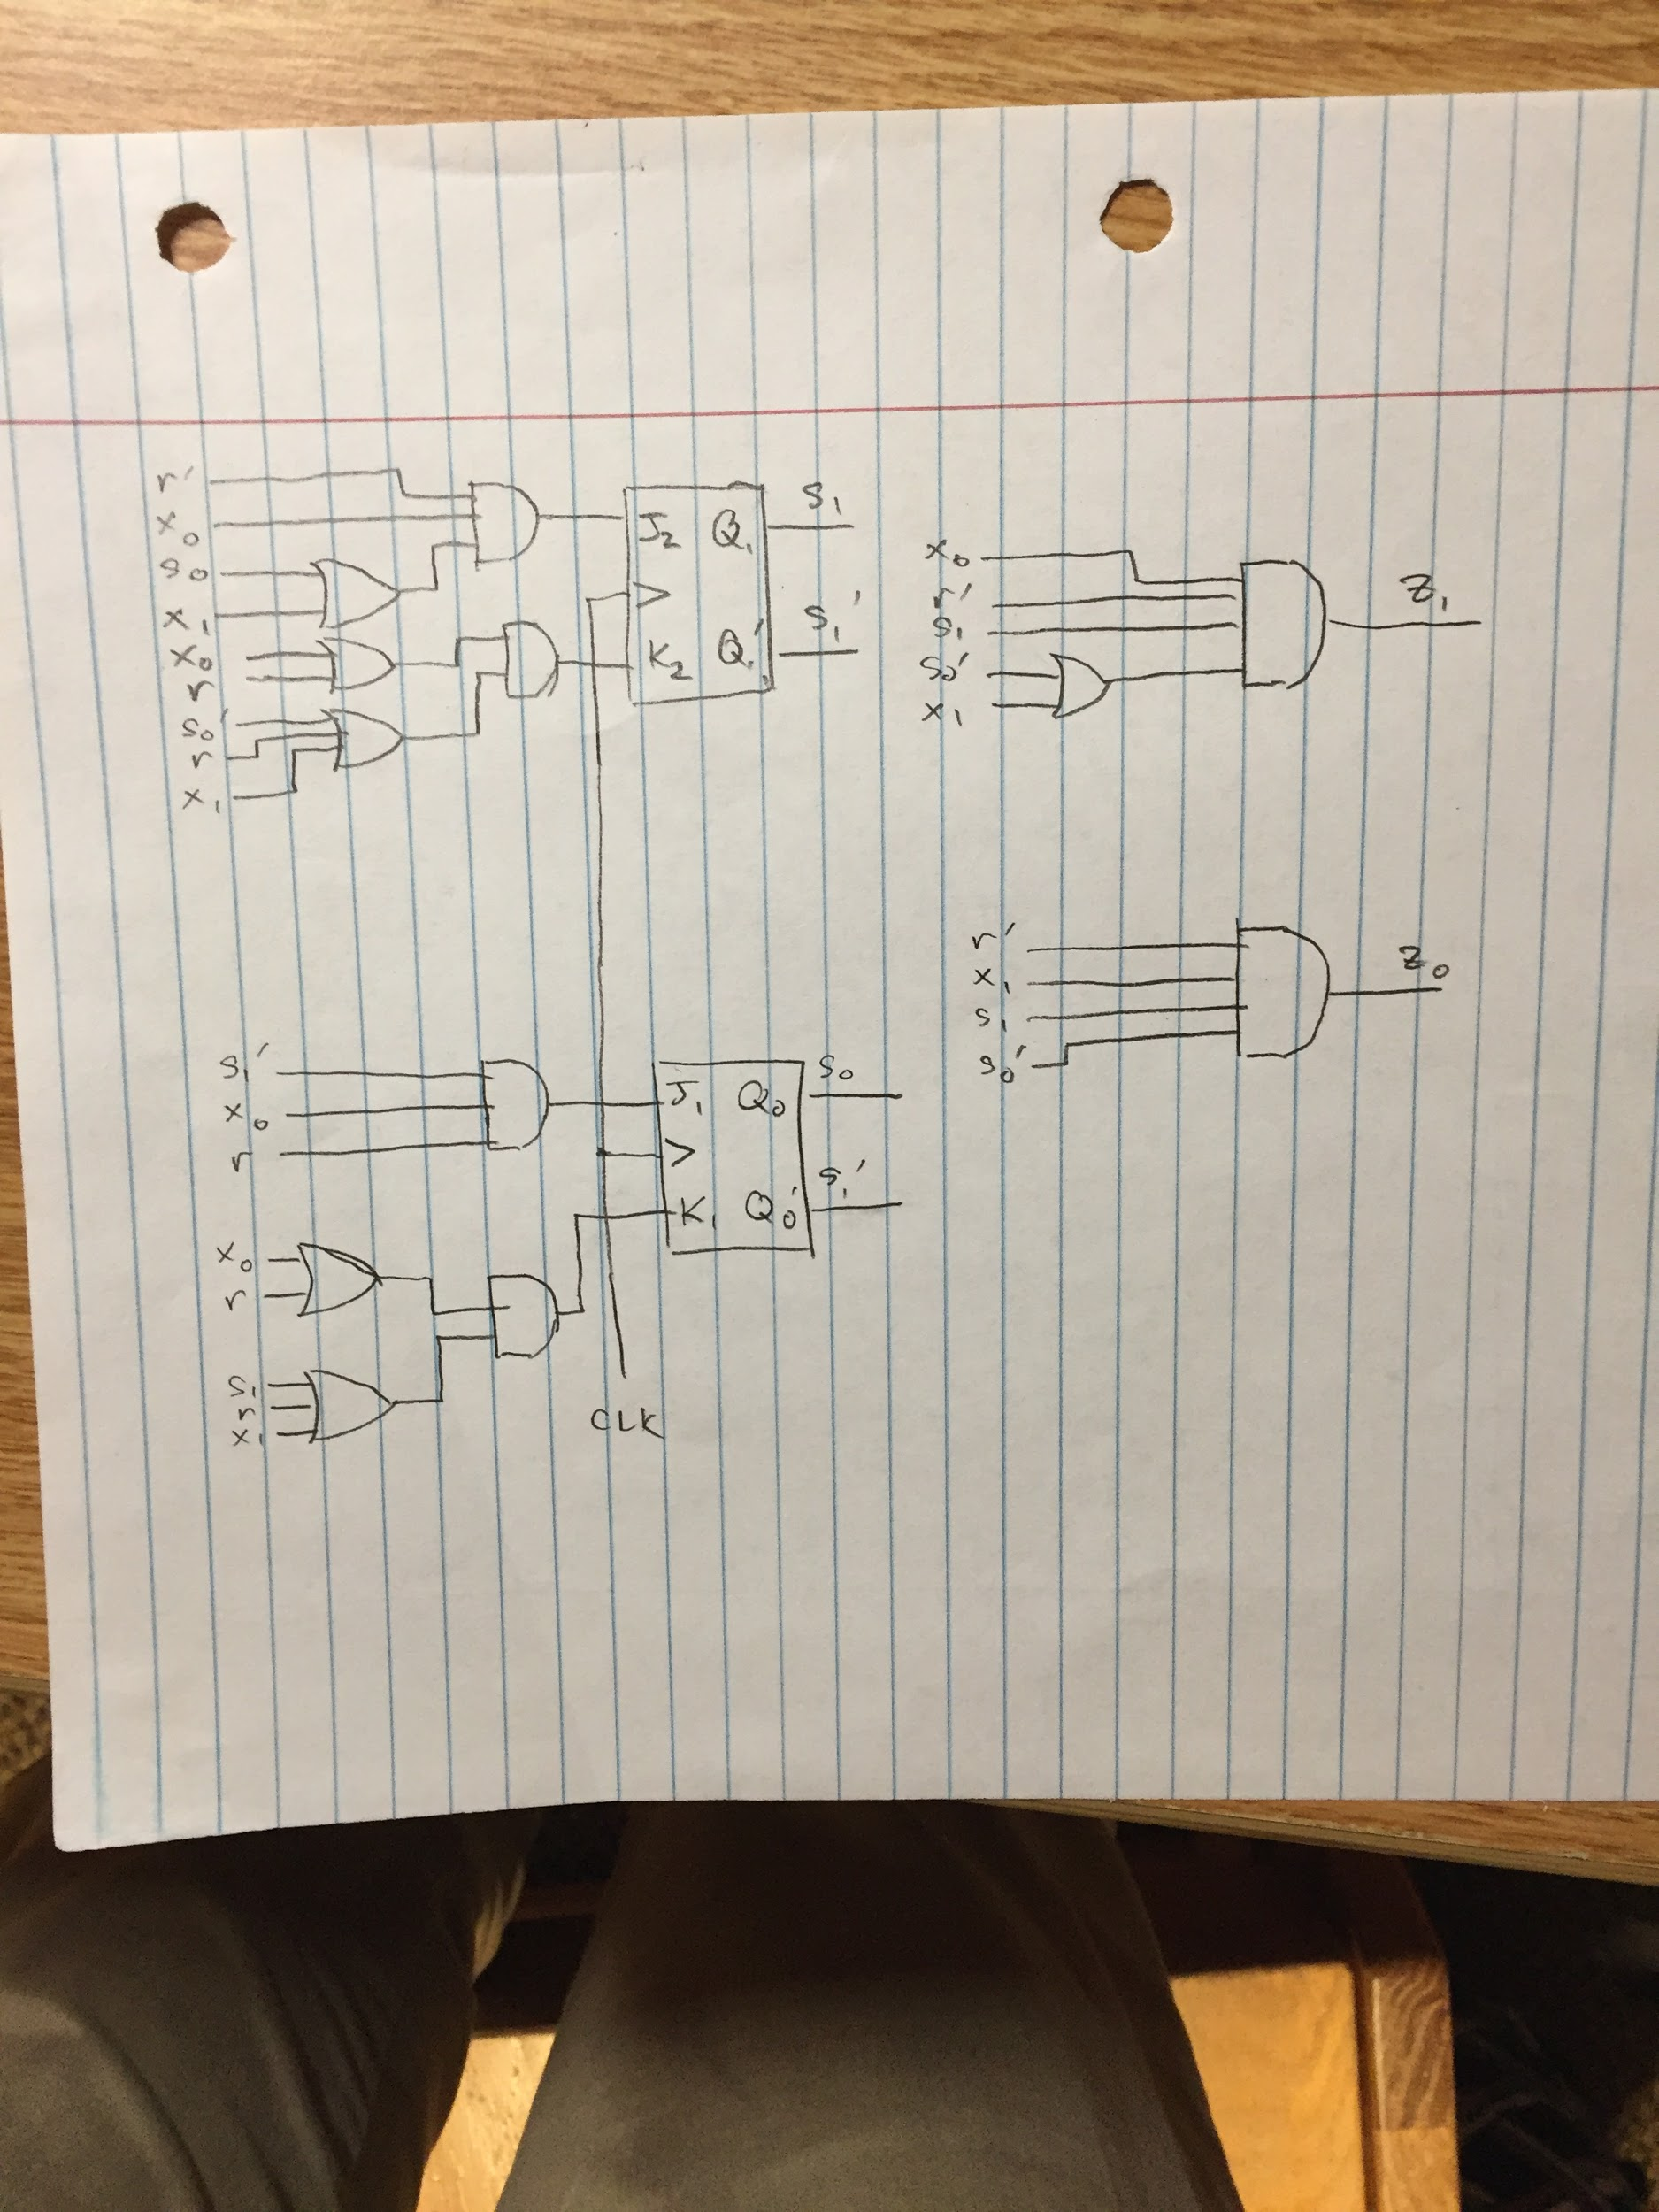 *Figure 2: A Simplified Schematic of the FSM*

The appendix contains the handwritten notes that provide work in determining the switching expressions (Figures 3, 4, 5, 6, 7).

1. *The Verilog Code*

It is attached.

1. *The Simulation Result*

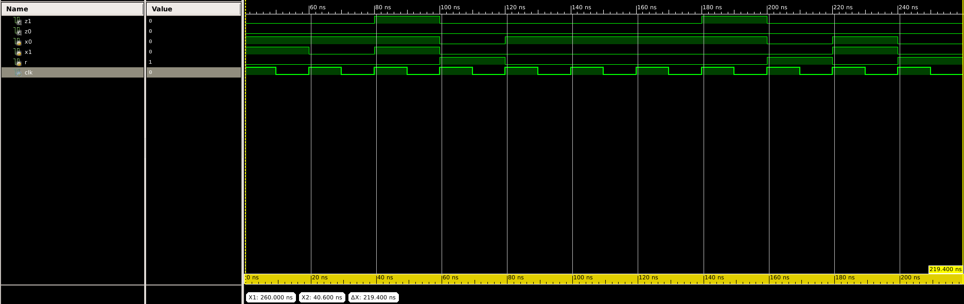The timing diagram above shows the outputs z1 and z0 when different inputs of x1x0r are input into the system. The first line is z1 and the second line represents z0. z1 and z0 follow the encodings for our output as described. z1 is meant to represent RG or release gum. z0 is RN, or return nickel. The third line is x0, and the fourth line is x1. This is meant to show the different coin inputs, as following the encoding, with 00 being nothing, 01 being a nickel, and 11 being a dime. The fifth line is r, with represents the reset variable. In our implementation, we decided to include reset as a variable and not include it as an asynchronous reset in our verilog file. The last line represents the clock signal. In the timing diagram above, the inputs DND (Dime, Nickel, Dime) are input, which results in z1 outputting 11 as the controller should release a gum and return a nickel. Then the controller is reset, then NNNN (4 Nickels) is input, and z1 again outputs 1. The controller is reset and a dime and reset is input, resulting in nothing.

1. *The Design Review*

The work we did for designing the circuit implementation was a strong reinforcement of what we had learned in class and problems involving flip-flops done on the homework. The most difficult part of the handwritten work was the K-maps. We opted for K-maps instead of the Quine-McCluskey method because Quine-McCluskey requires a lot of comparisons and work. The K-maps needed to be 3-dimensional but it was a far easier method, despite our inexperience with 5 or more input K-maps.

One main issue that we encountered while working on this project was the implementation of our system in Verilog code. There were few tutorials available online on how to create a sequential system using JK flip flops. To overcome this issue, we had to utilize multiple tutorials online to understand the logic behind the verilog code. We combined tutorials for implementing a JK flip flop by itself, creating a Finite State Machine (FSM), and combining multiple Verilog Modules together. After writing our main .v files for both the JK Flip Flop and the overall controller, we were tasked with creating a test bench file to test our system. This proved incredibly difficult as even fewer tutorials were available. In addition, multiple bugs occured with certain implementations that were hard to understand. The most time was spent trying to debug our test bench file. One such issue with the test bench file that we encountered was the outputs not outputting a logical value. In our simulation, z1 and z0 outputted x, which in verilog means an illogical statement.

1. *Team Member Contributions*

Lucas- 46%

Derrick- 54%

Lucas- helped write out state tables and excitation table, did minimization of the expressions with 5-input K-maps, wrote large parts of the report

Derrick- helped write the encodings and tables, coded the verilog file and the test bench file, wrote large parts of the report

1. *Appendix - The detailed design worksheet*

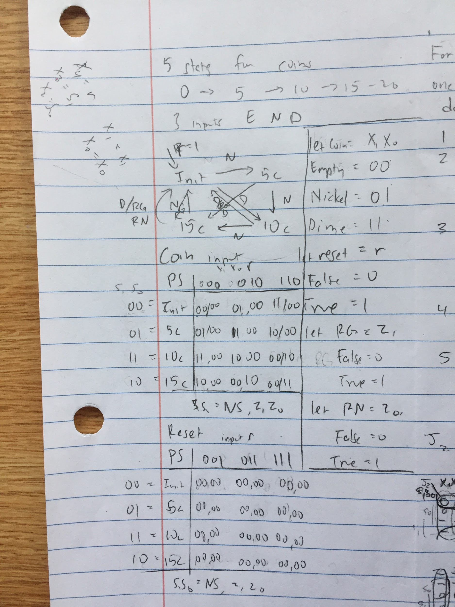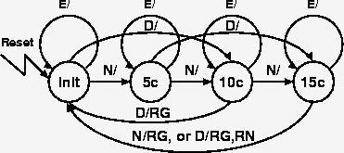

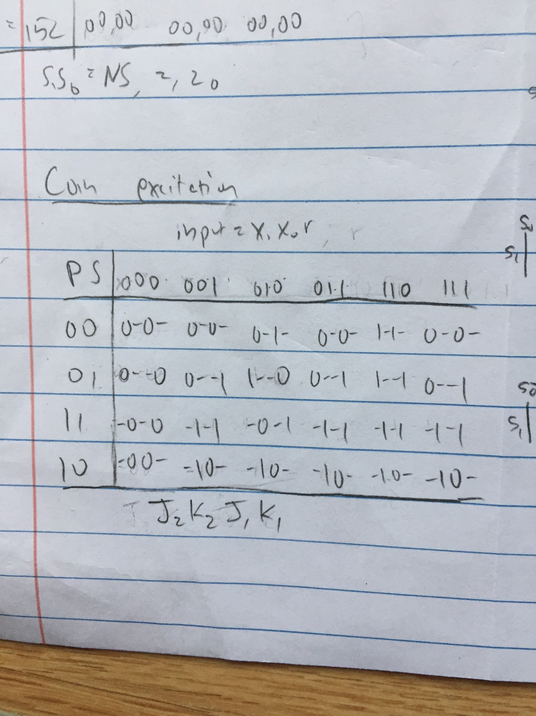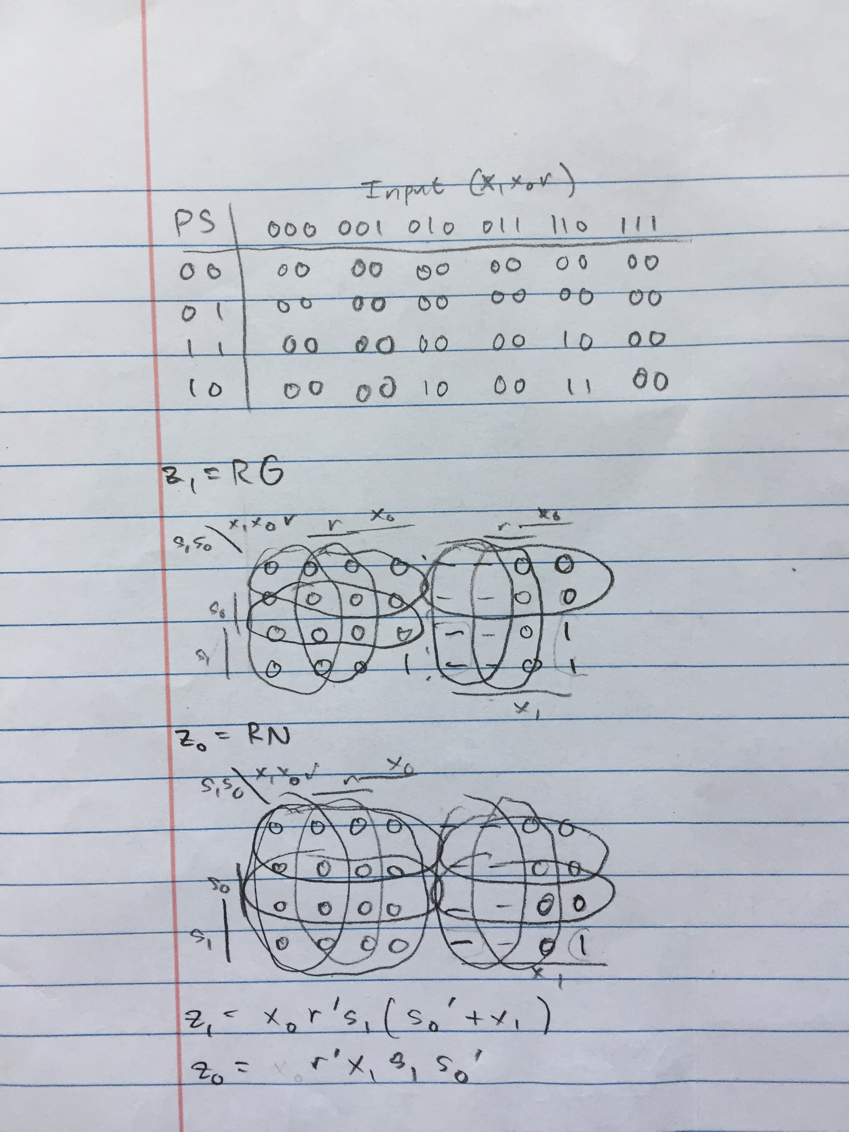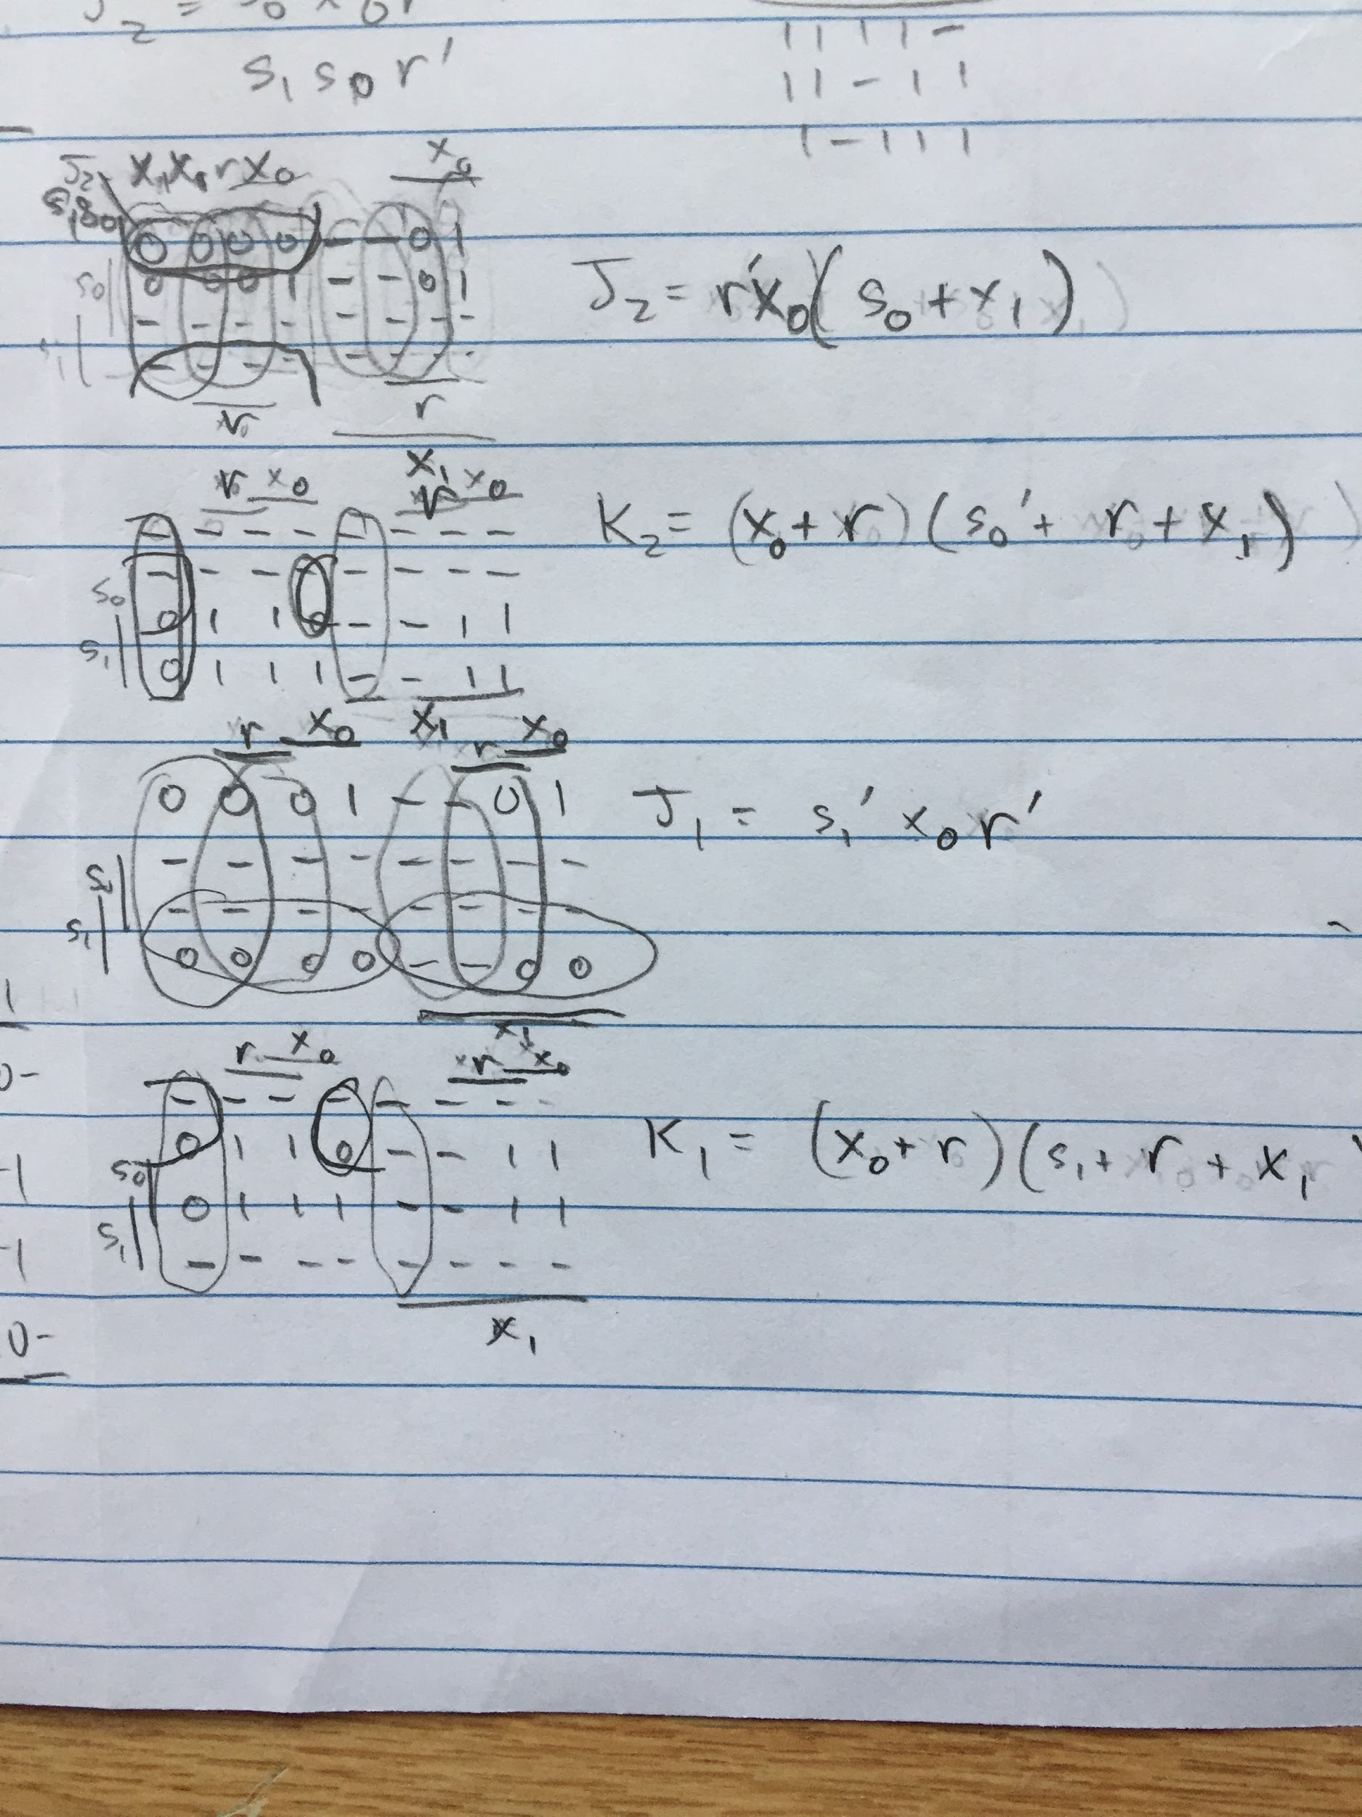

*Figures 3, 4, 5, 6, 7: Handwritten/Given Work of the Inputs, Outputs, Encodings, State Tables, State Diagram, Minimization Process With K-maps*

*Figure 2: A Simplified Schematic of the FSM**Figure 1: Schematic of the FSM*